Providing “Help” for input variables
Liz Quigg
Update: June 19, 2013

I describe using annotations for variables defined for TRs to display information about the input variable to support “Help”. This pertains to the Cosmic e-Lab only because LIGO and CMS do not use transformations defined in the VDS.

There are two jsp pages that support adding the annotation of the variables associated with the transformations. These are described below. The original method of adding the annotation used “Chiron” – a user interface that allowed the definition of transformations and their input variables. This was not updated as the University of Chicago team developed new versions of software to support grid execution.

If we annotate all the input variables that the user will see in our skins, then we can put a little ? link next to each input variable that opens up a page which displays the value of the “description” metadata tag for the variable.

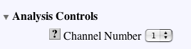

I tested it with the FluxStudyNoThresh TR and the input variable singlechannel_channel. The long name of the variable makes it inappropriate as the name you might want to display so I added an additional parameter “label”.

Here is the code that appears with the form for entering the channel. It uses a javascript function “describe” which calls a jsp called dispDescription.jsp and displays the description for the variable for a TR.

<td align="right" width="40% valign="bottom <a href="javascript: describe('Quarknet.Cosmic::FluxStudyNoThresh','singlechannel_channel','Channel')"><IMG SRC="graphics/question.gif"></A>

Channel Number
</td>
<td>
<select name="singlechannel_channel">
<option value="1">1</option>
<option value="2">2</option>
<option value="3">3</option>

</td>

It uses the image question.gif and javascript to open a new window with a small size with the url dispDescription.jsp. It passes the full name of the transformation (tr) and the argument name (arg), and finally the label you want to appear. Clicking on the question mark will display something like the following in a small window.
Channel in the title.

You have to know the full name of the TR and argument you are using. You have to have use code to set it. (dispDescription.jsp).

Another feature is that these annotations can have links and images in them so they can point to more information or they can display a graphic. Once the description metadata is entered for a variable, it is displayed as html so to recover any definition that has html, you have to look at the source. Any links should also include target=new so they open a big window as appropriate.

Example of an image:

Disadvantages:
1) Currently every time you use a TR to build another TR, you have to go and comment all the arguments again, unless we write separate code to set these. You have to refer to the correct TR in the code that displays the form. Currently Paul does not define the TR being used in the analysis until he invokes doAnalysis.jsp. We may want to put this code sooner or in two places so analysis.jsp has access to it (in particular analyse_flux_options.jsp).
2) For the plot parameters, each analysis has its own set of input parameters associated with the analysis (flux, lifetime, or shower). If we want to use the compound TR as the TR name we pass, then we will have to enter the descriptions for all of the plot variables for each of the compound TRs. If we want to refer to them as they are in the simple TR Plot, then we could annotate the variables for the simple TR and reference them in the call to dispDescription.jsp. The latter is the solution I chose for all studies except the shower study where we have a 3D-graph. So I used the plot arguments associated with ShowerStudyNoThresh rather than those associated with the simple Plot transform.

3) Not all the items that need additional help information are variables so we will have to build a glossary as well. The glossary could have diagrams in it, too.

Nevertheless, it seems like a promising way to annotate the input variables in the various analysis skins and provide information in the Chiron portal.

Currently we are using strings for these annotations. In the future we could consider using text which would allow for more than 255 characters. The links take quite a few characters!

Steps to add annotations:
1) go to the e-Lab and log in as admin.
2) type in the URL like the one below with the transformation and argument names: http://www.i2u2.org/elab/cosmic/jsp/editDescription.jsp?tr=I2U2.Cosmic::PerformanceStudy&arg=freq_binValue
3) enter html code and Click “Update”.

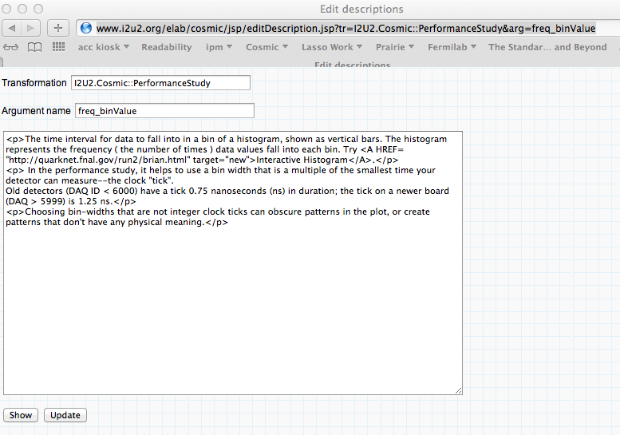

I have not tried this with a completely new transformation. The ones we have were originally created with Chiron. These could probably be created with a command-line interface.

If you just want to look at the code for a input variable associated with a transformation, use dispDescription.jsp

To add links, use the full path (Note: we may want to use relative paths and not worry that it does not show up in Chiron.)
<A HREF= "http://quarknet.fnal.gov/run2/brian.html" target=”new”>Interactive Histogram</A>

To show a graphic.
<IMG SRC= "quarknet.uchicago.edu/elab/cosmic/graphics/sh_min_max.gif">

This means that if you are developing in one portal, you should put the graphics you make for your explanation in the currently active portal. They must also be put into CVS.

Note: Previously, we had to go to the options.jsp include file for each study and add the appropriate call to describe for each input variable. In the current version, these must come out of the analysis code and do not have to be added. I am not sure of this!

LIGO – the annotations are done with links to the wiki glossary item.

CMS – I don’t seen any annotations in the analysis, but there is a link from the HELP that goes to the FAQs which are stored in the wiki.
onclick="javascript:window.open('\/library\/kiwi.php?title=CMS_FAQ', 'faq',…

